# SOLUTION 1.1

## Greedy Best First Search [MediumMaze.txt]

**Path Explored : 78 Path Cost : 74**

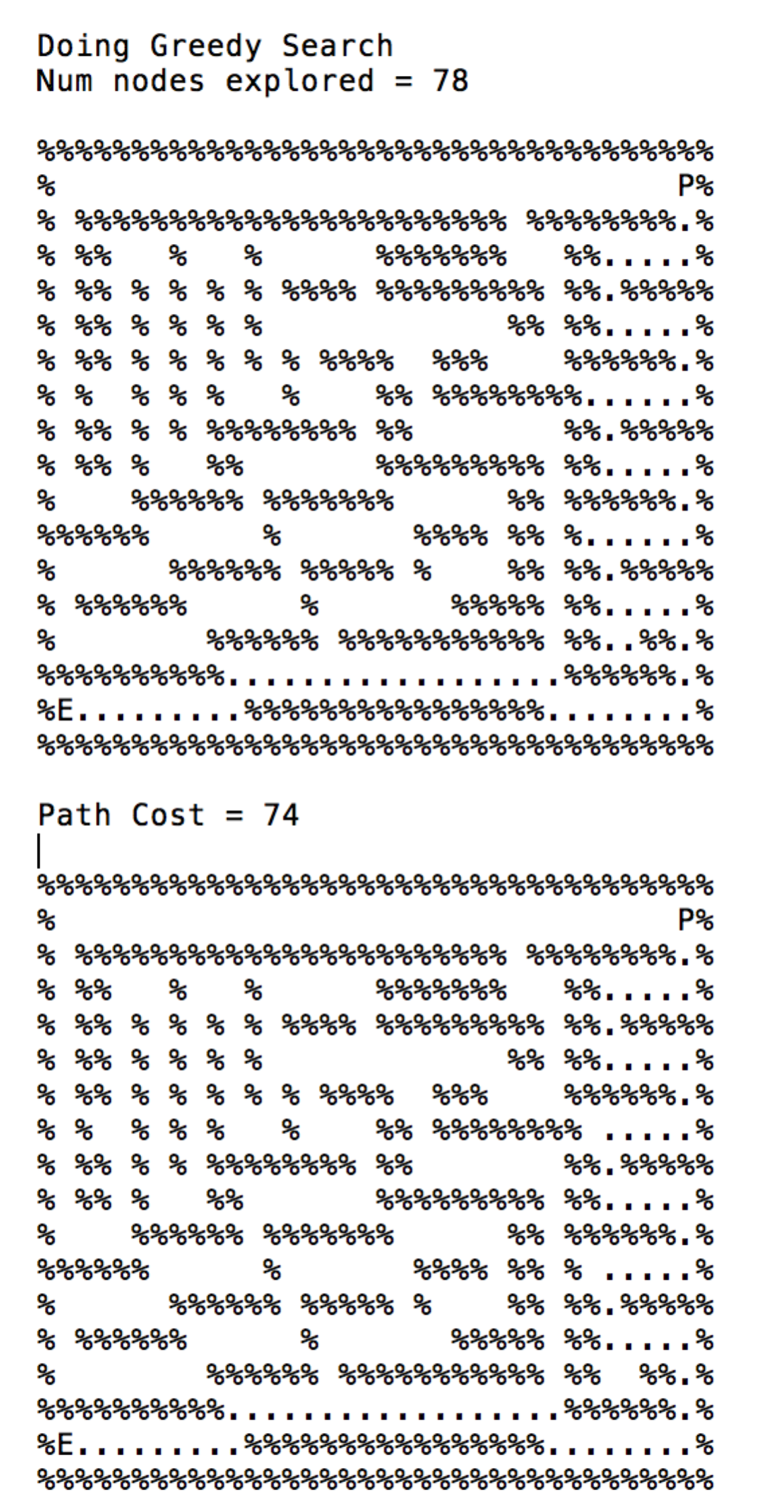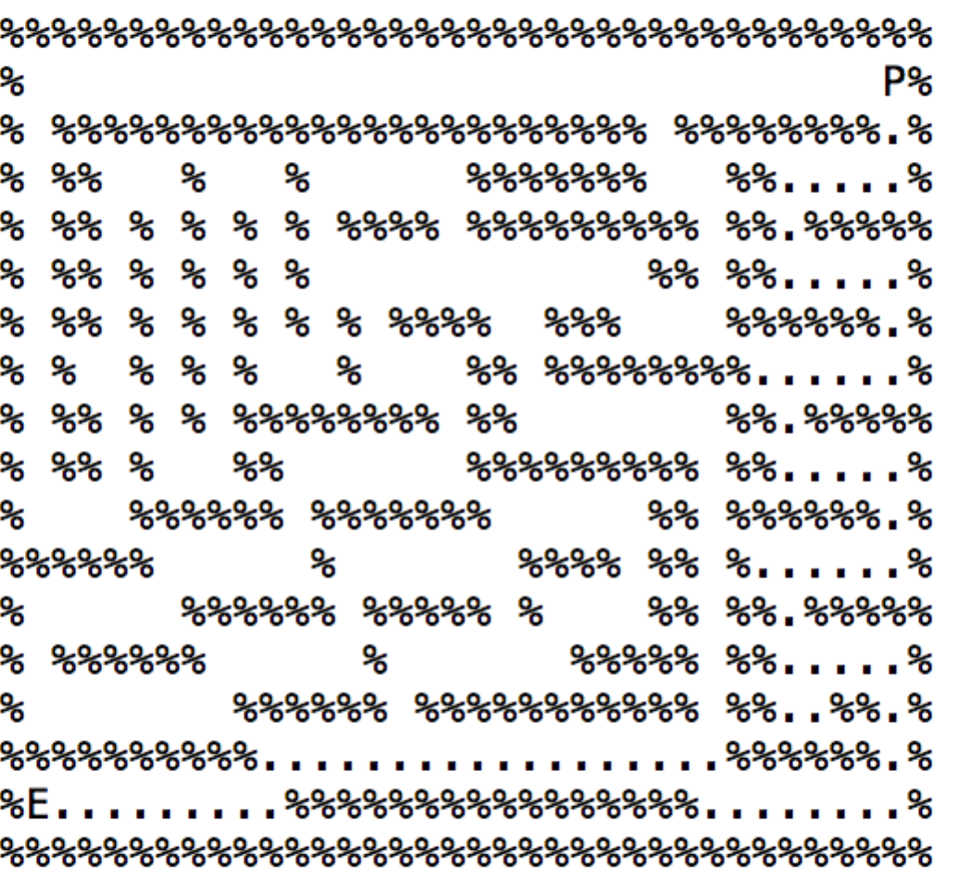

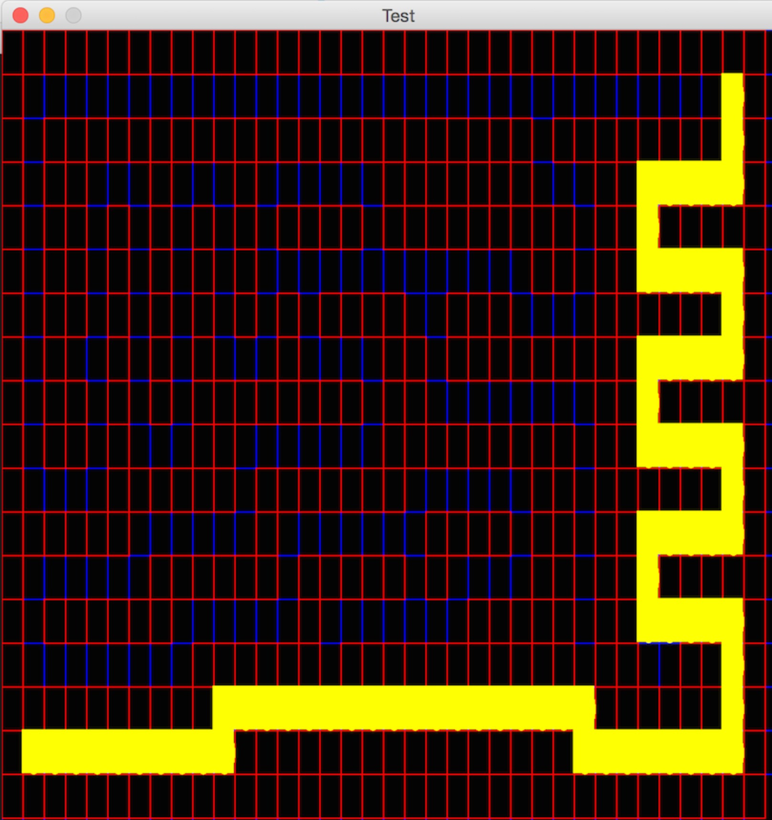

**Greedy Search Path Trace**

## Bread First Search [MediumMaze.txt]

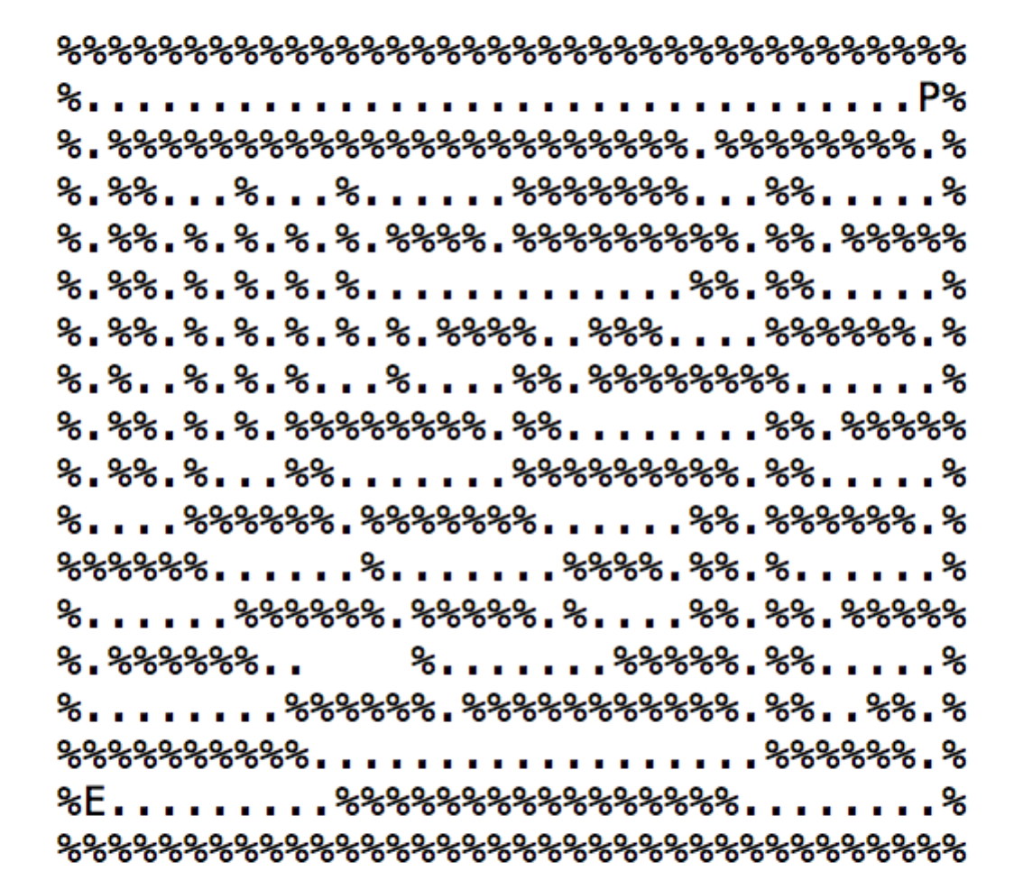**Path Explored : 269 Path Cost : 68**

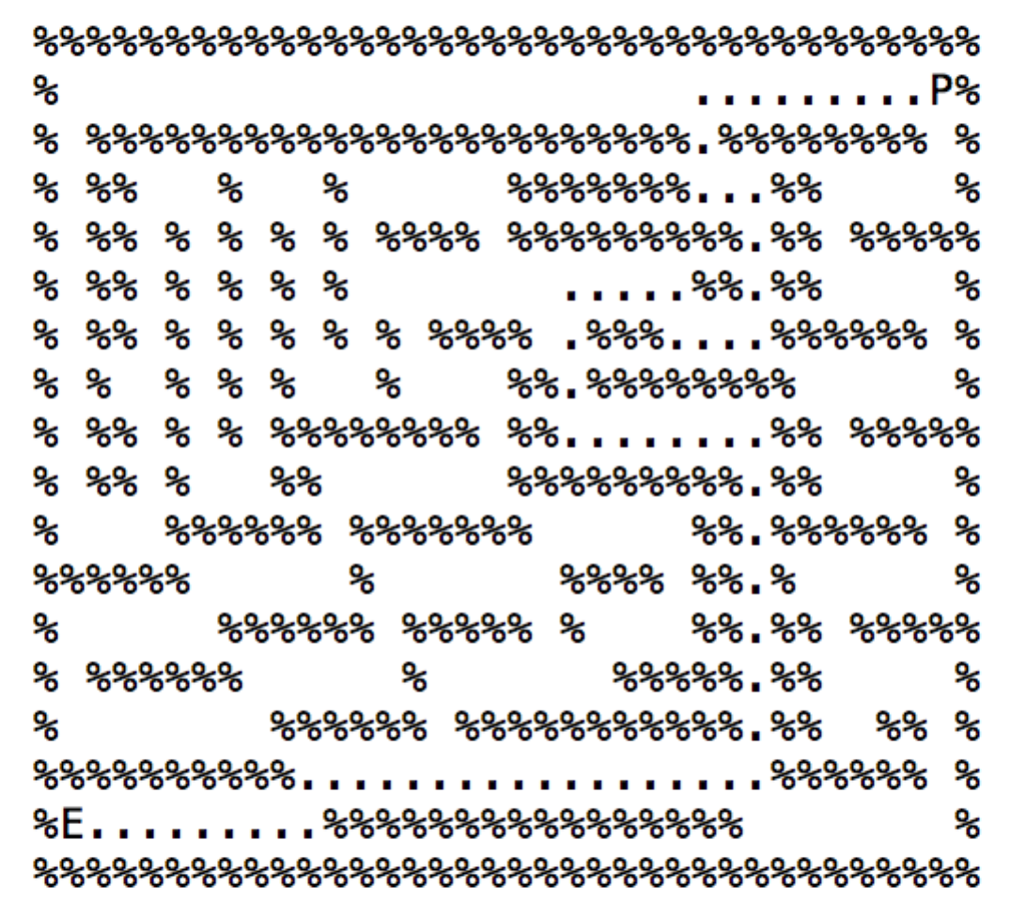

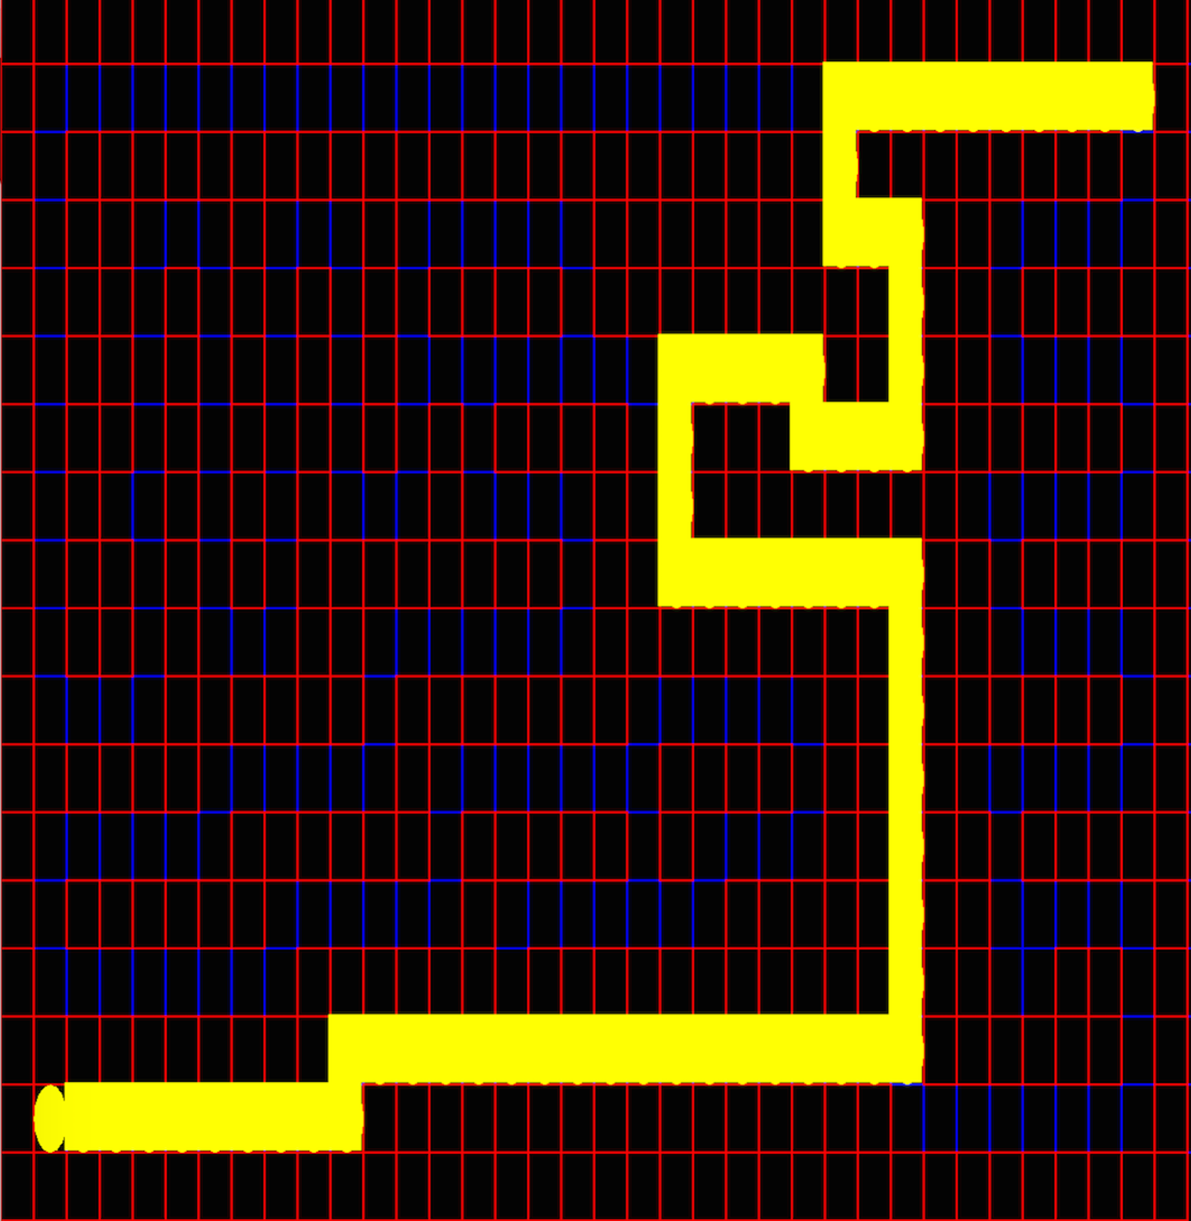

**Breadth First Search Path Trace**

## Depth First Search [MediumMaze.txt]

**Path Explored : 144 Path Cost : 130**

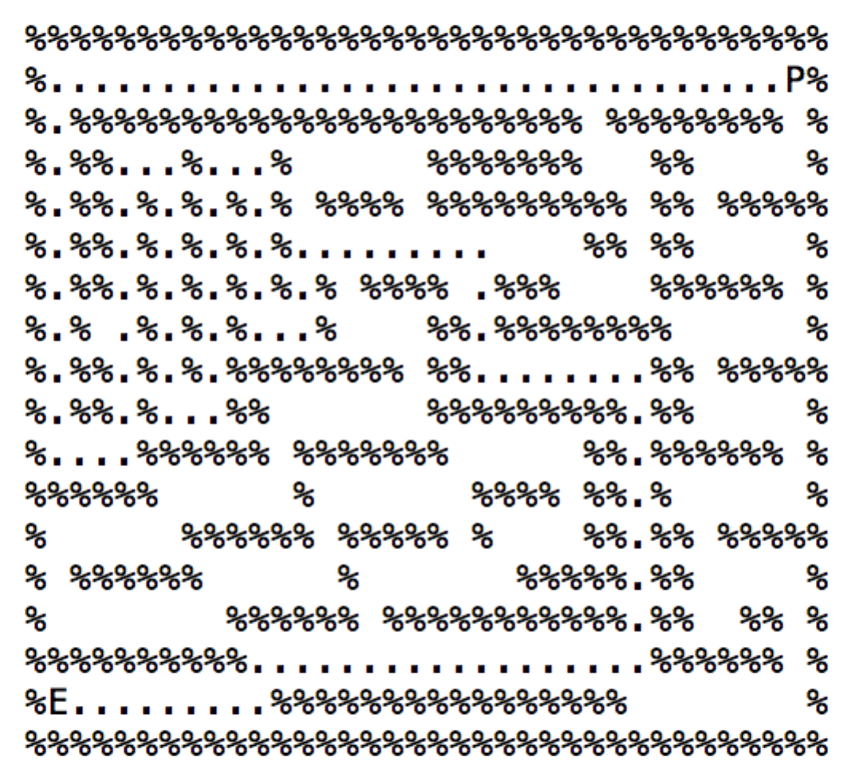

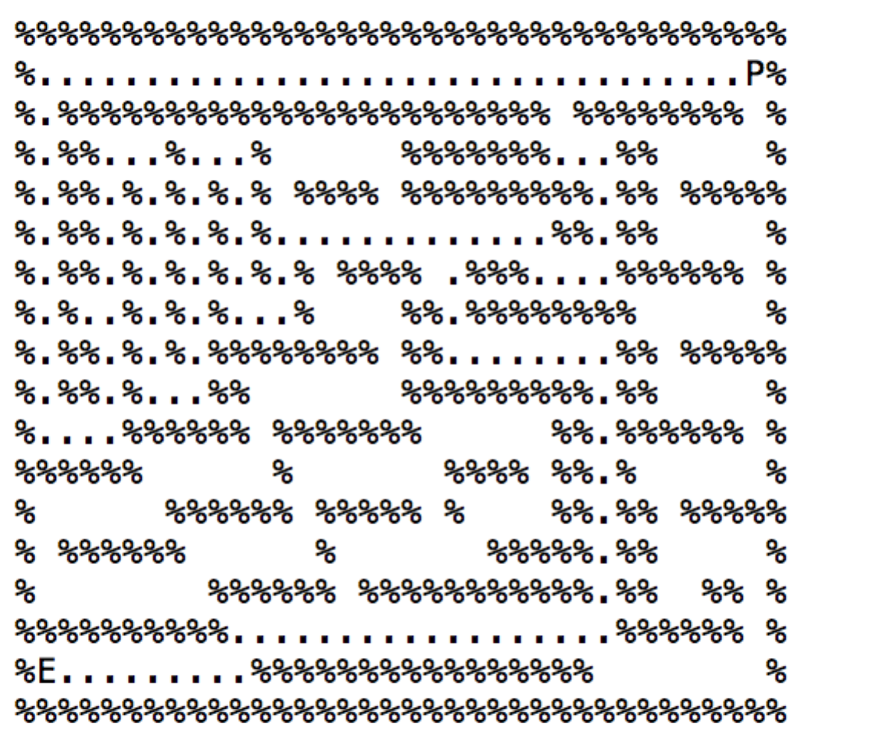

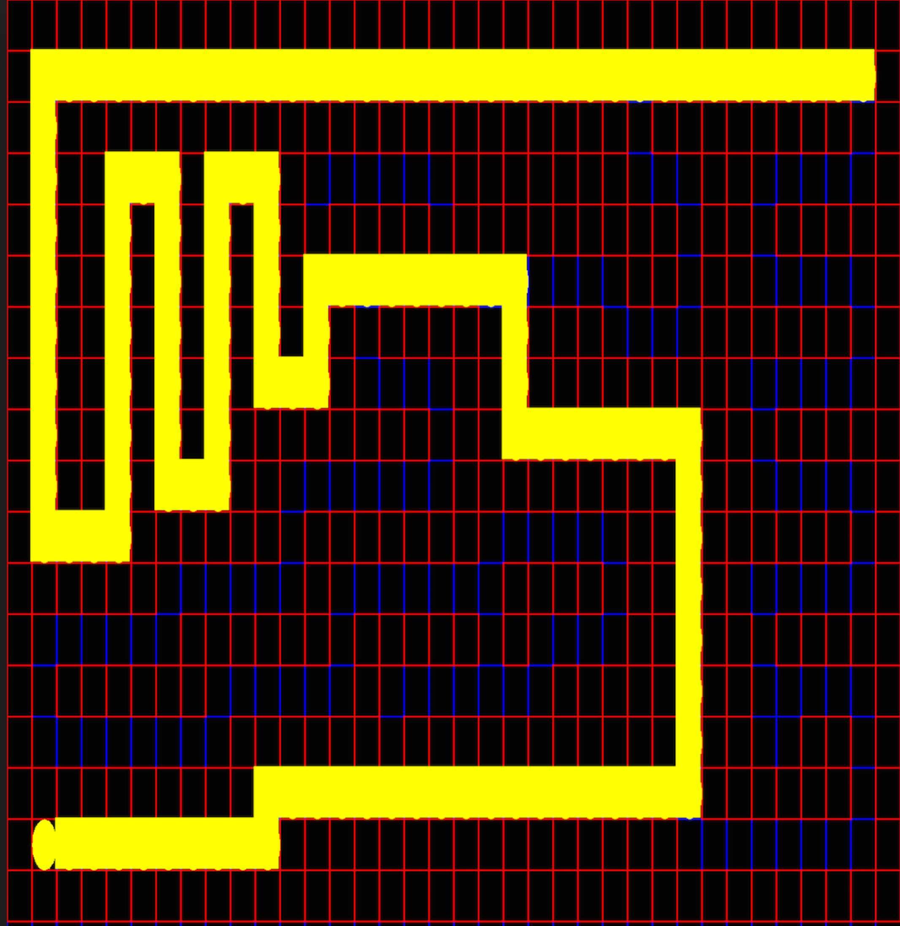

**Depth First Search Path Trace**

## ASTAR First Search [MediumMaze.txt]

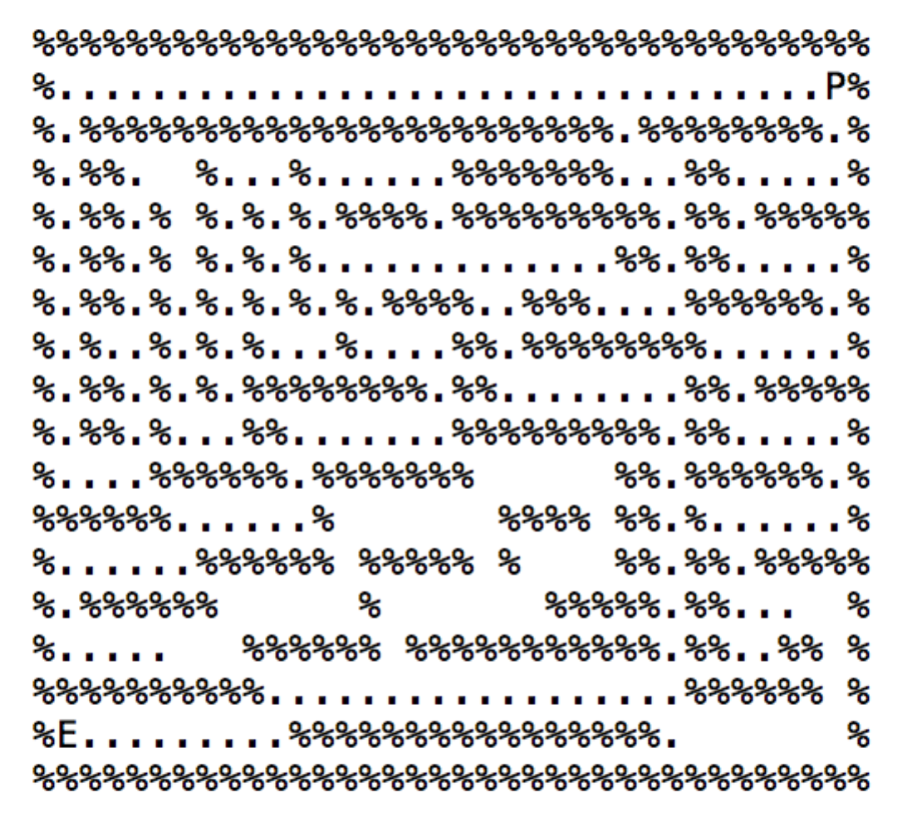**Path Explored : 222 Path Cost : 68**

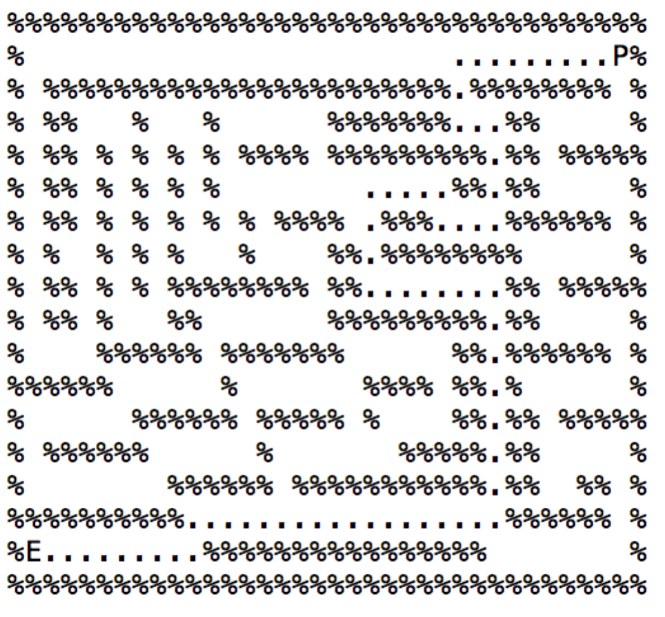

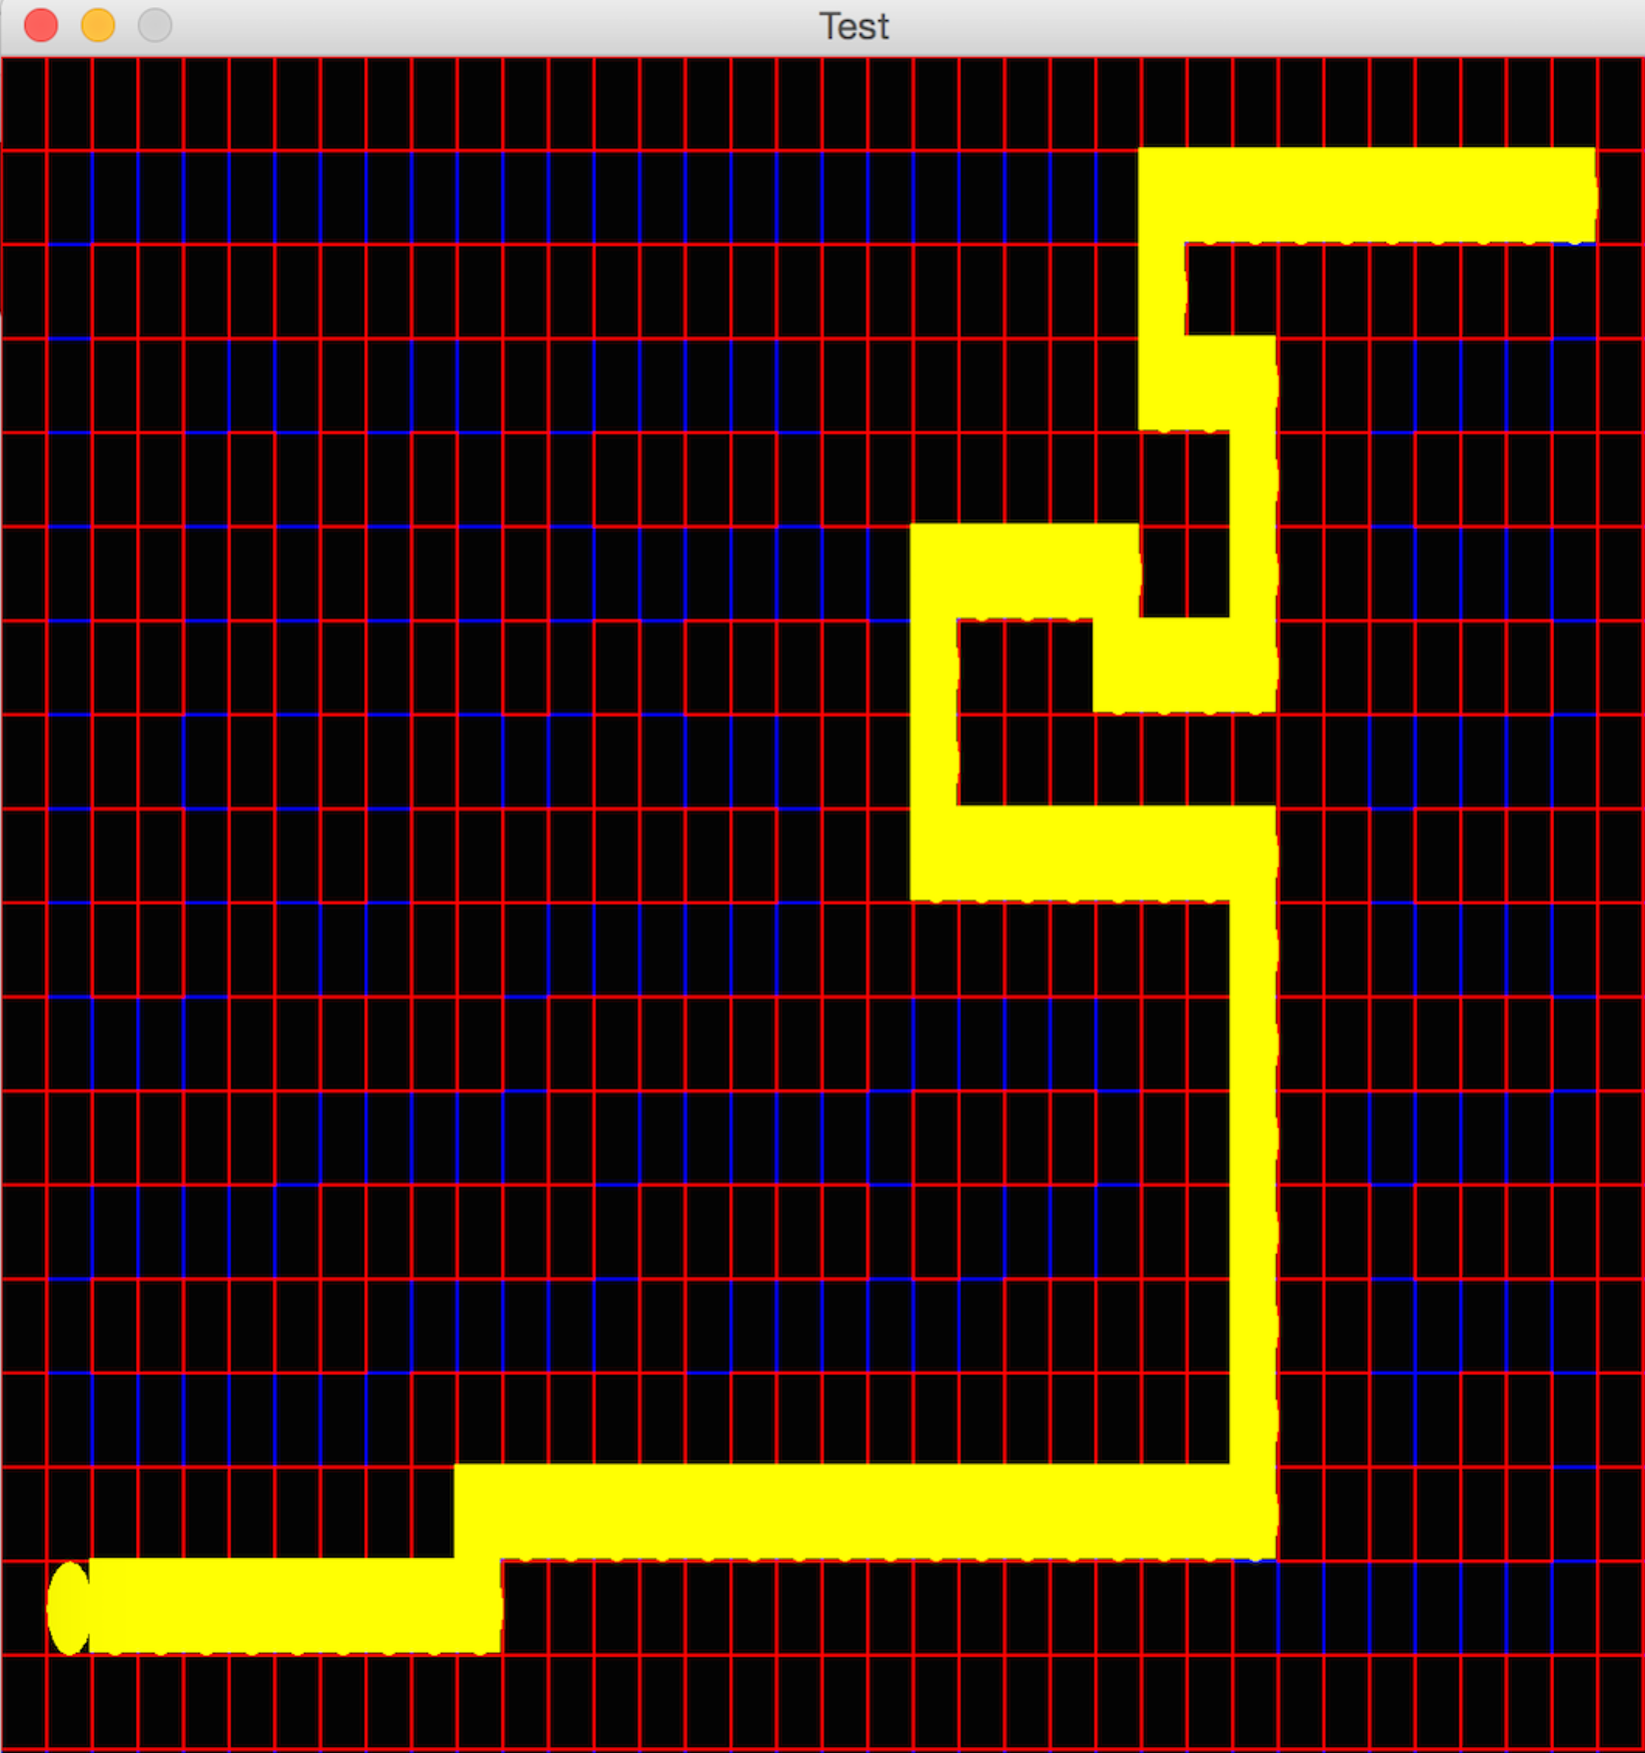

**ASTAR First Search Path Trace**

# INPUT SmallMaze.txt

## Depth First Search [smallMaze.txt]

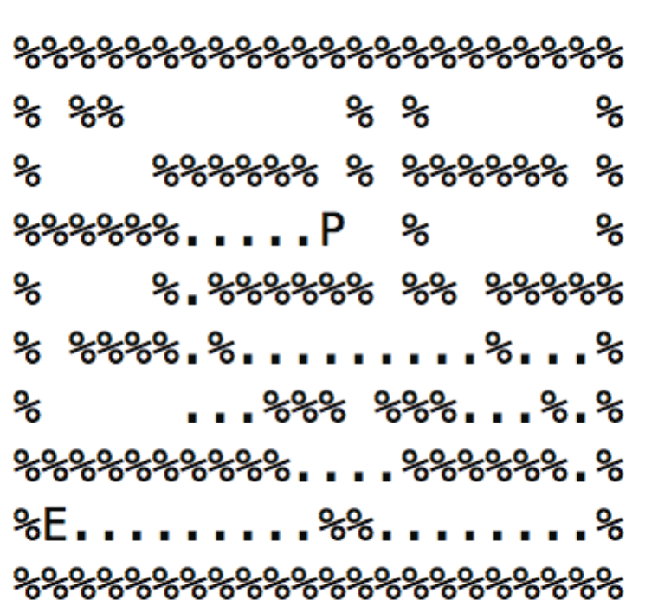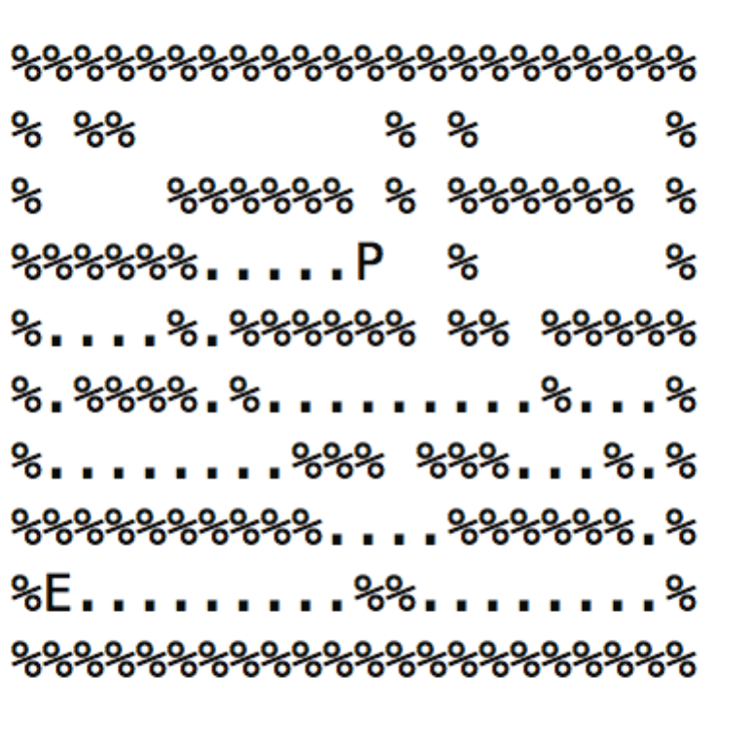**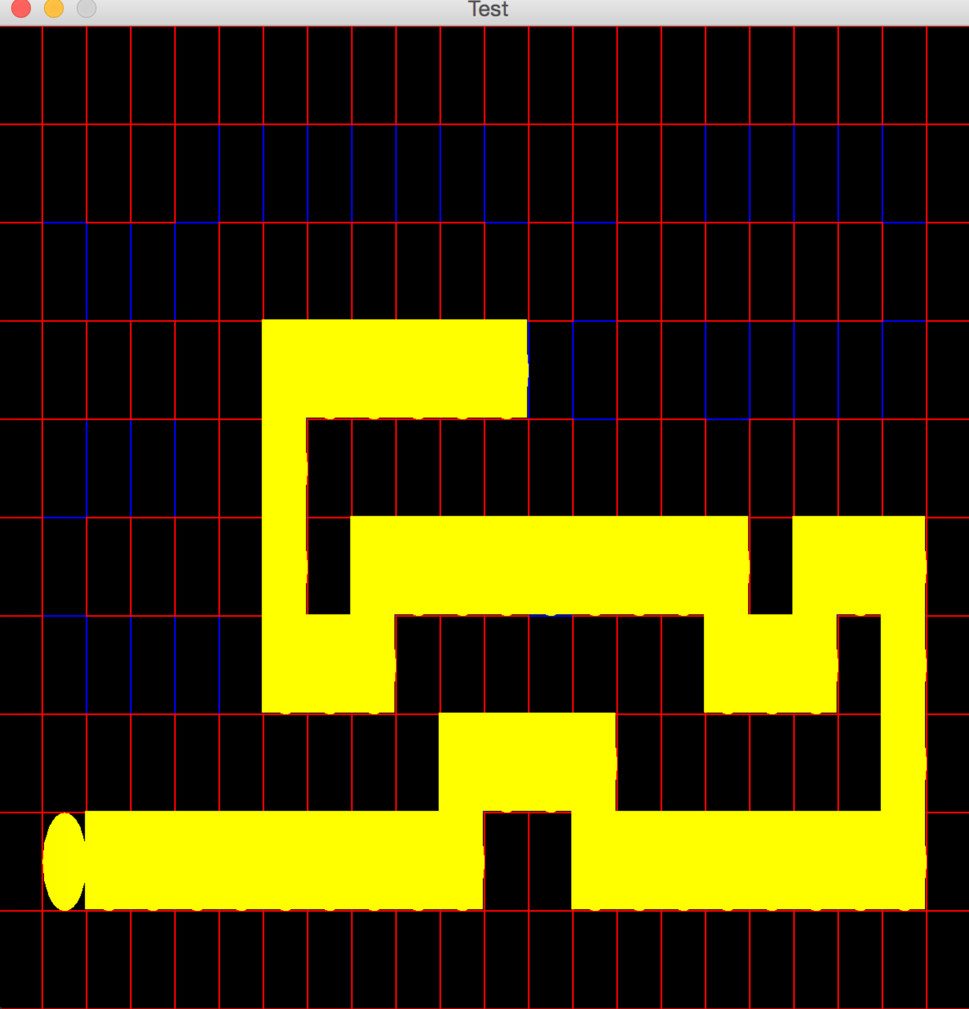Path Explored : 59 Path Cost : 49**

**Depth First Search Path Trace**

## Breadth First Search [smallMaze.txt]

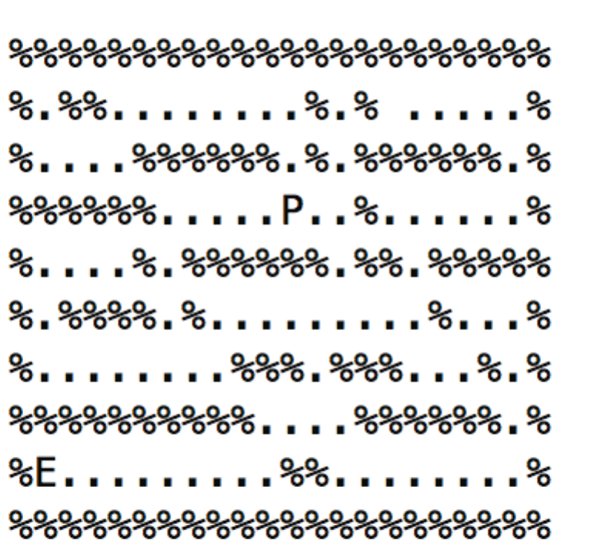**Path Explored : 92 Path Cost : 19**

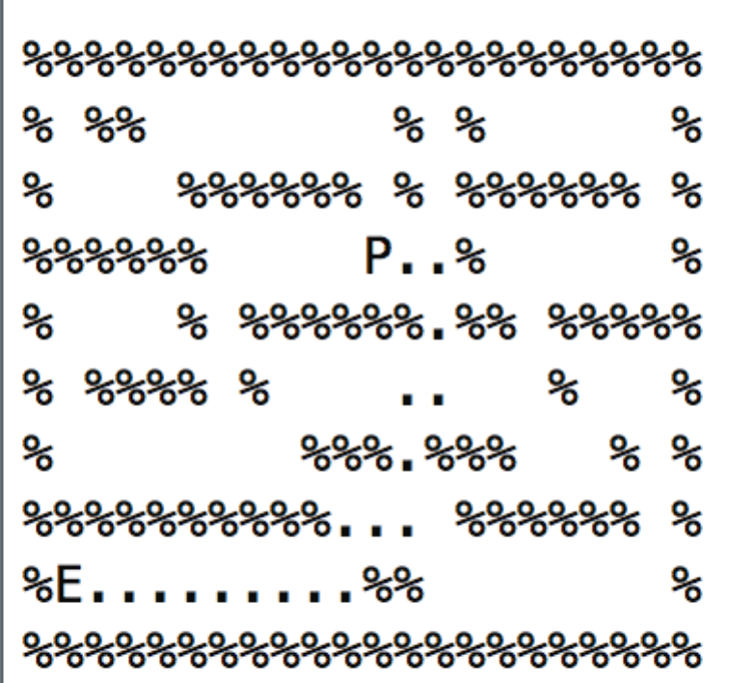

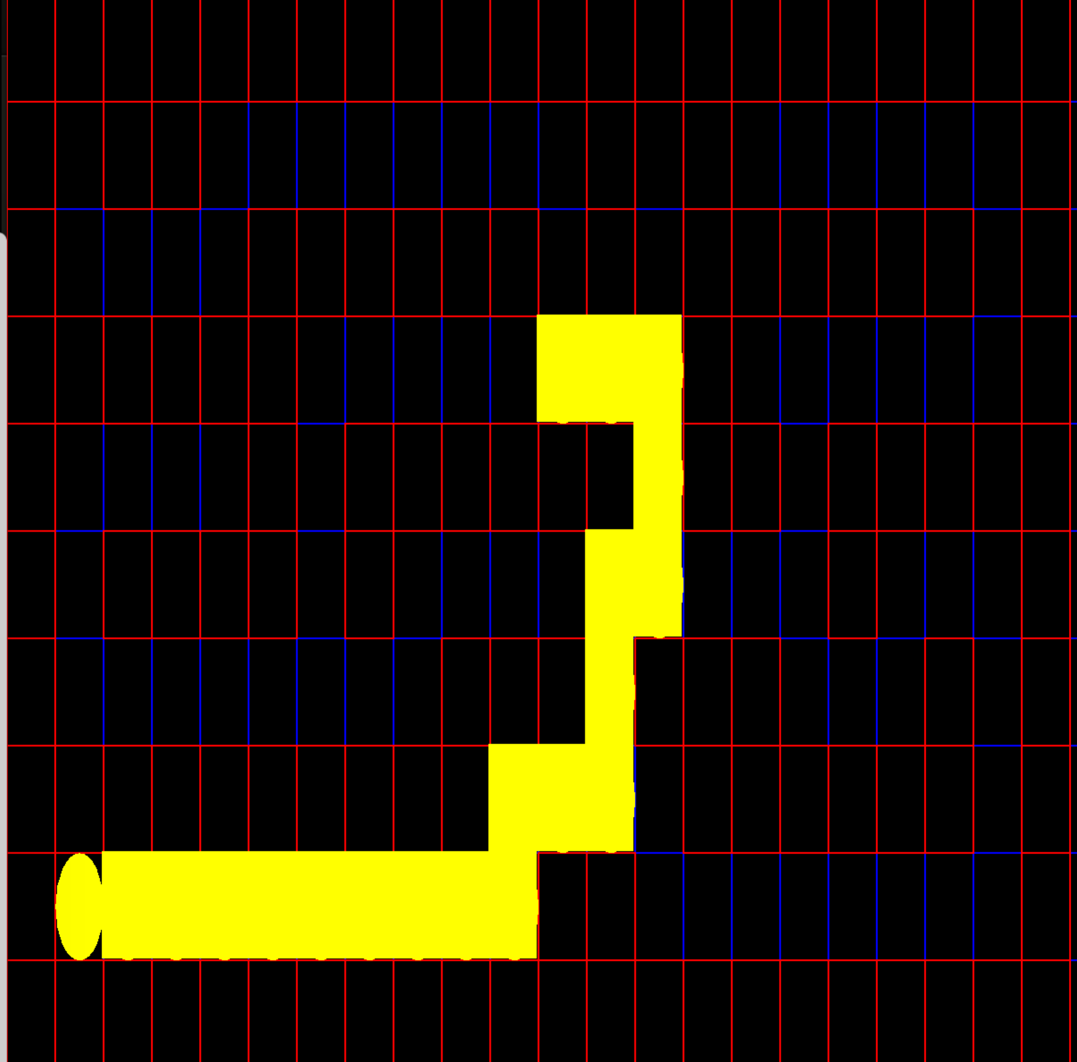**Breadth First Search Path Trace**

## Greedy Best First Search [smallMaze.txt]

**Path Explored : 39 Path Cost : 29**

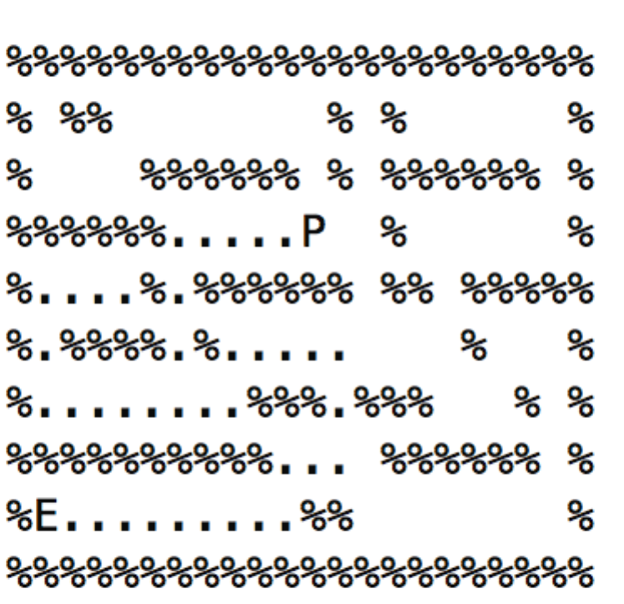

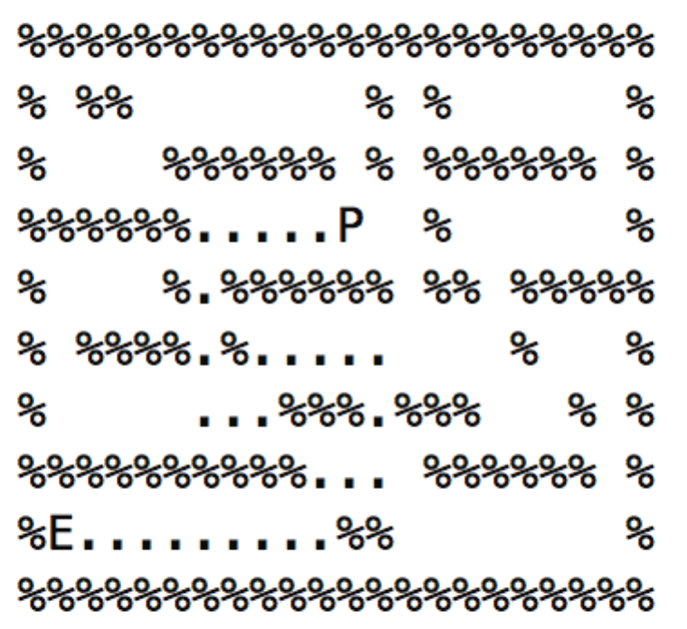

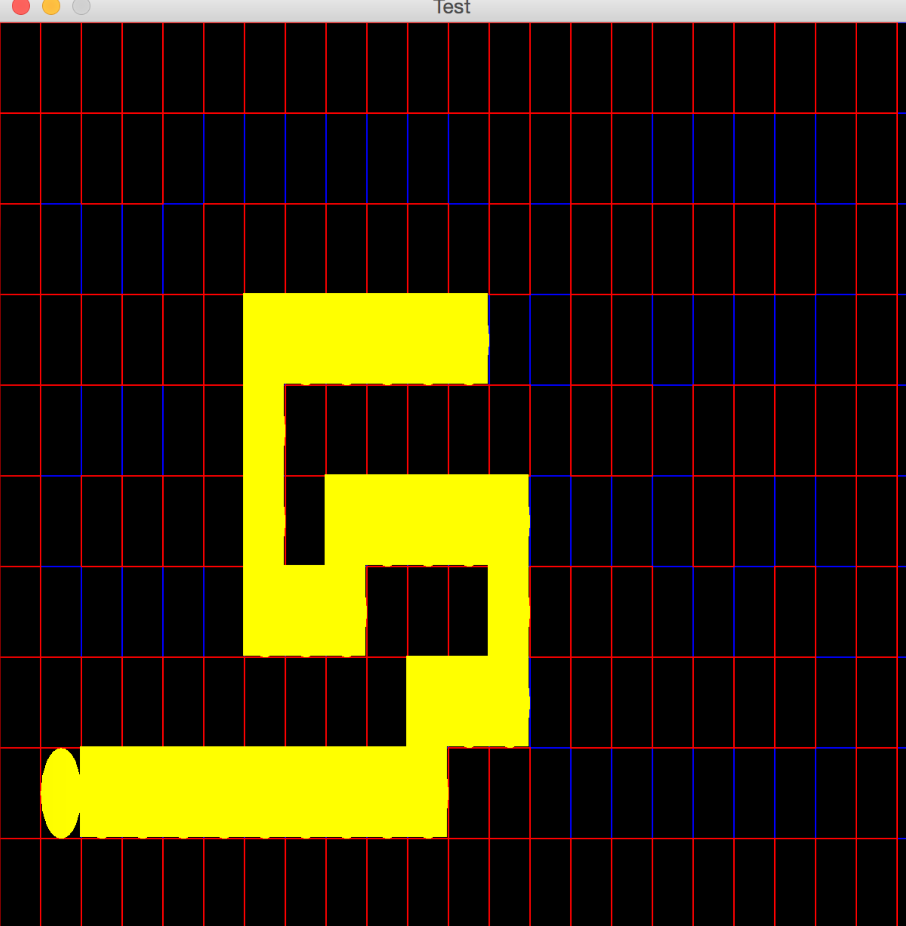

**Greedy Best First Search Path Trace**

## ASTAR Search [smallMaze.txt]

**Path Explored : 53 Path Cost : 19**

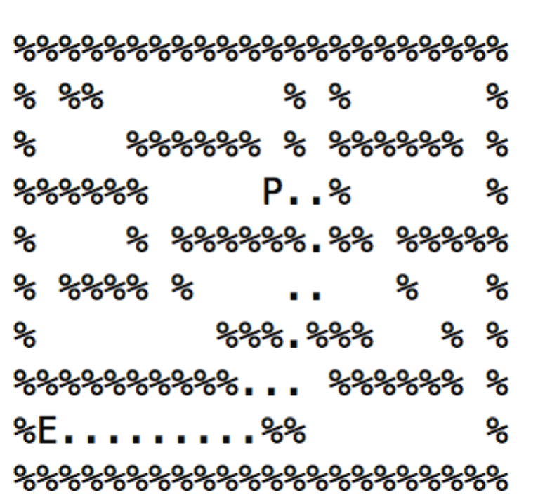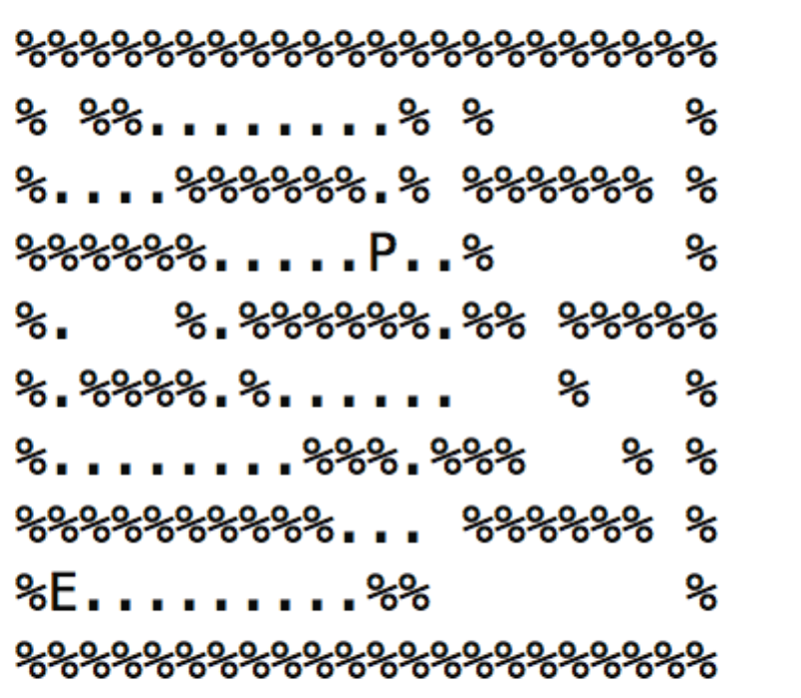

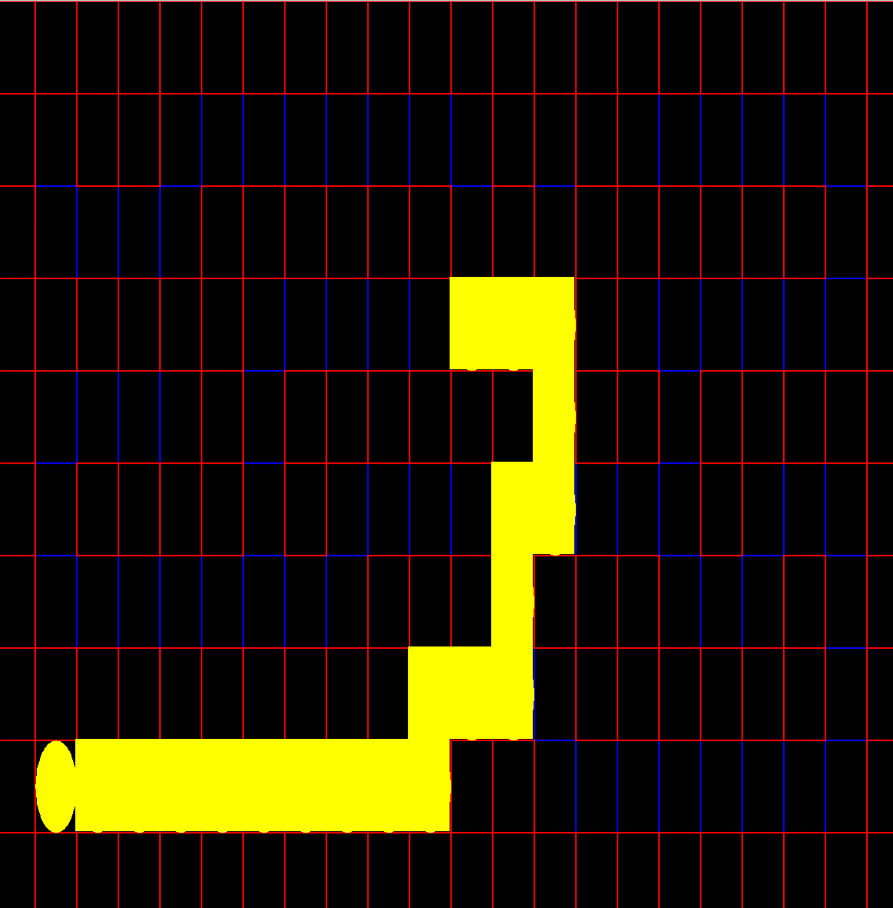

**ASTAR Search Path Trace**

## Depth First Search [bigMaze.txt]

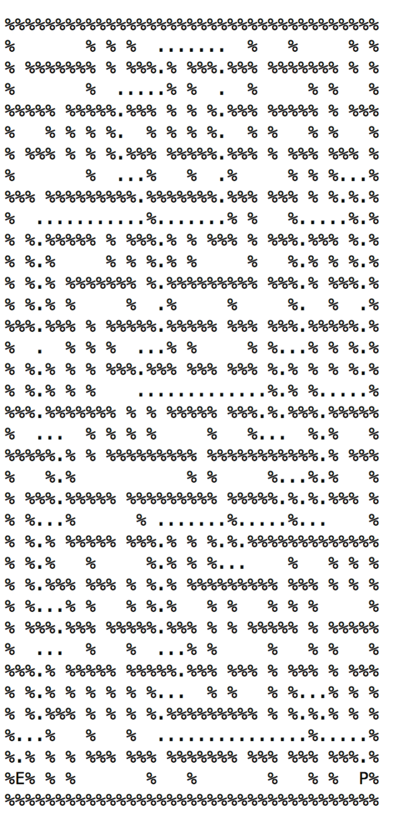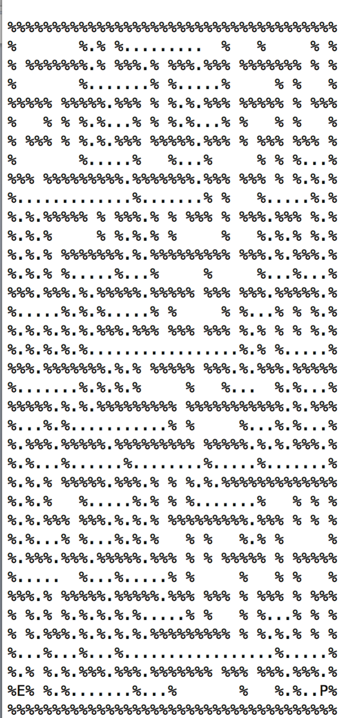**Path Explored : 390 Path Cost : 210**

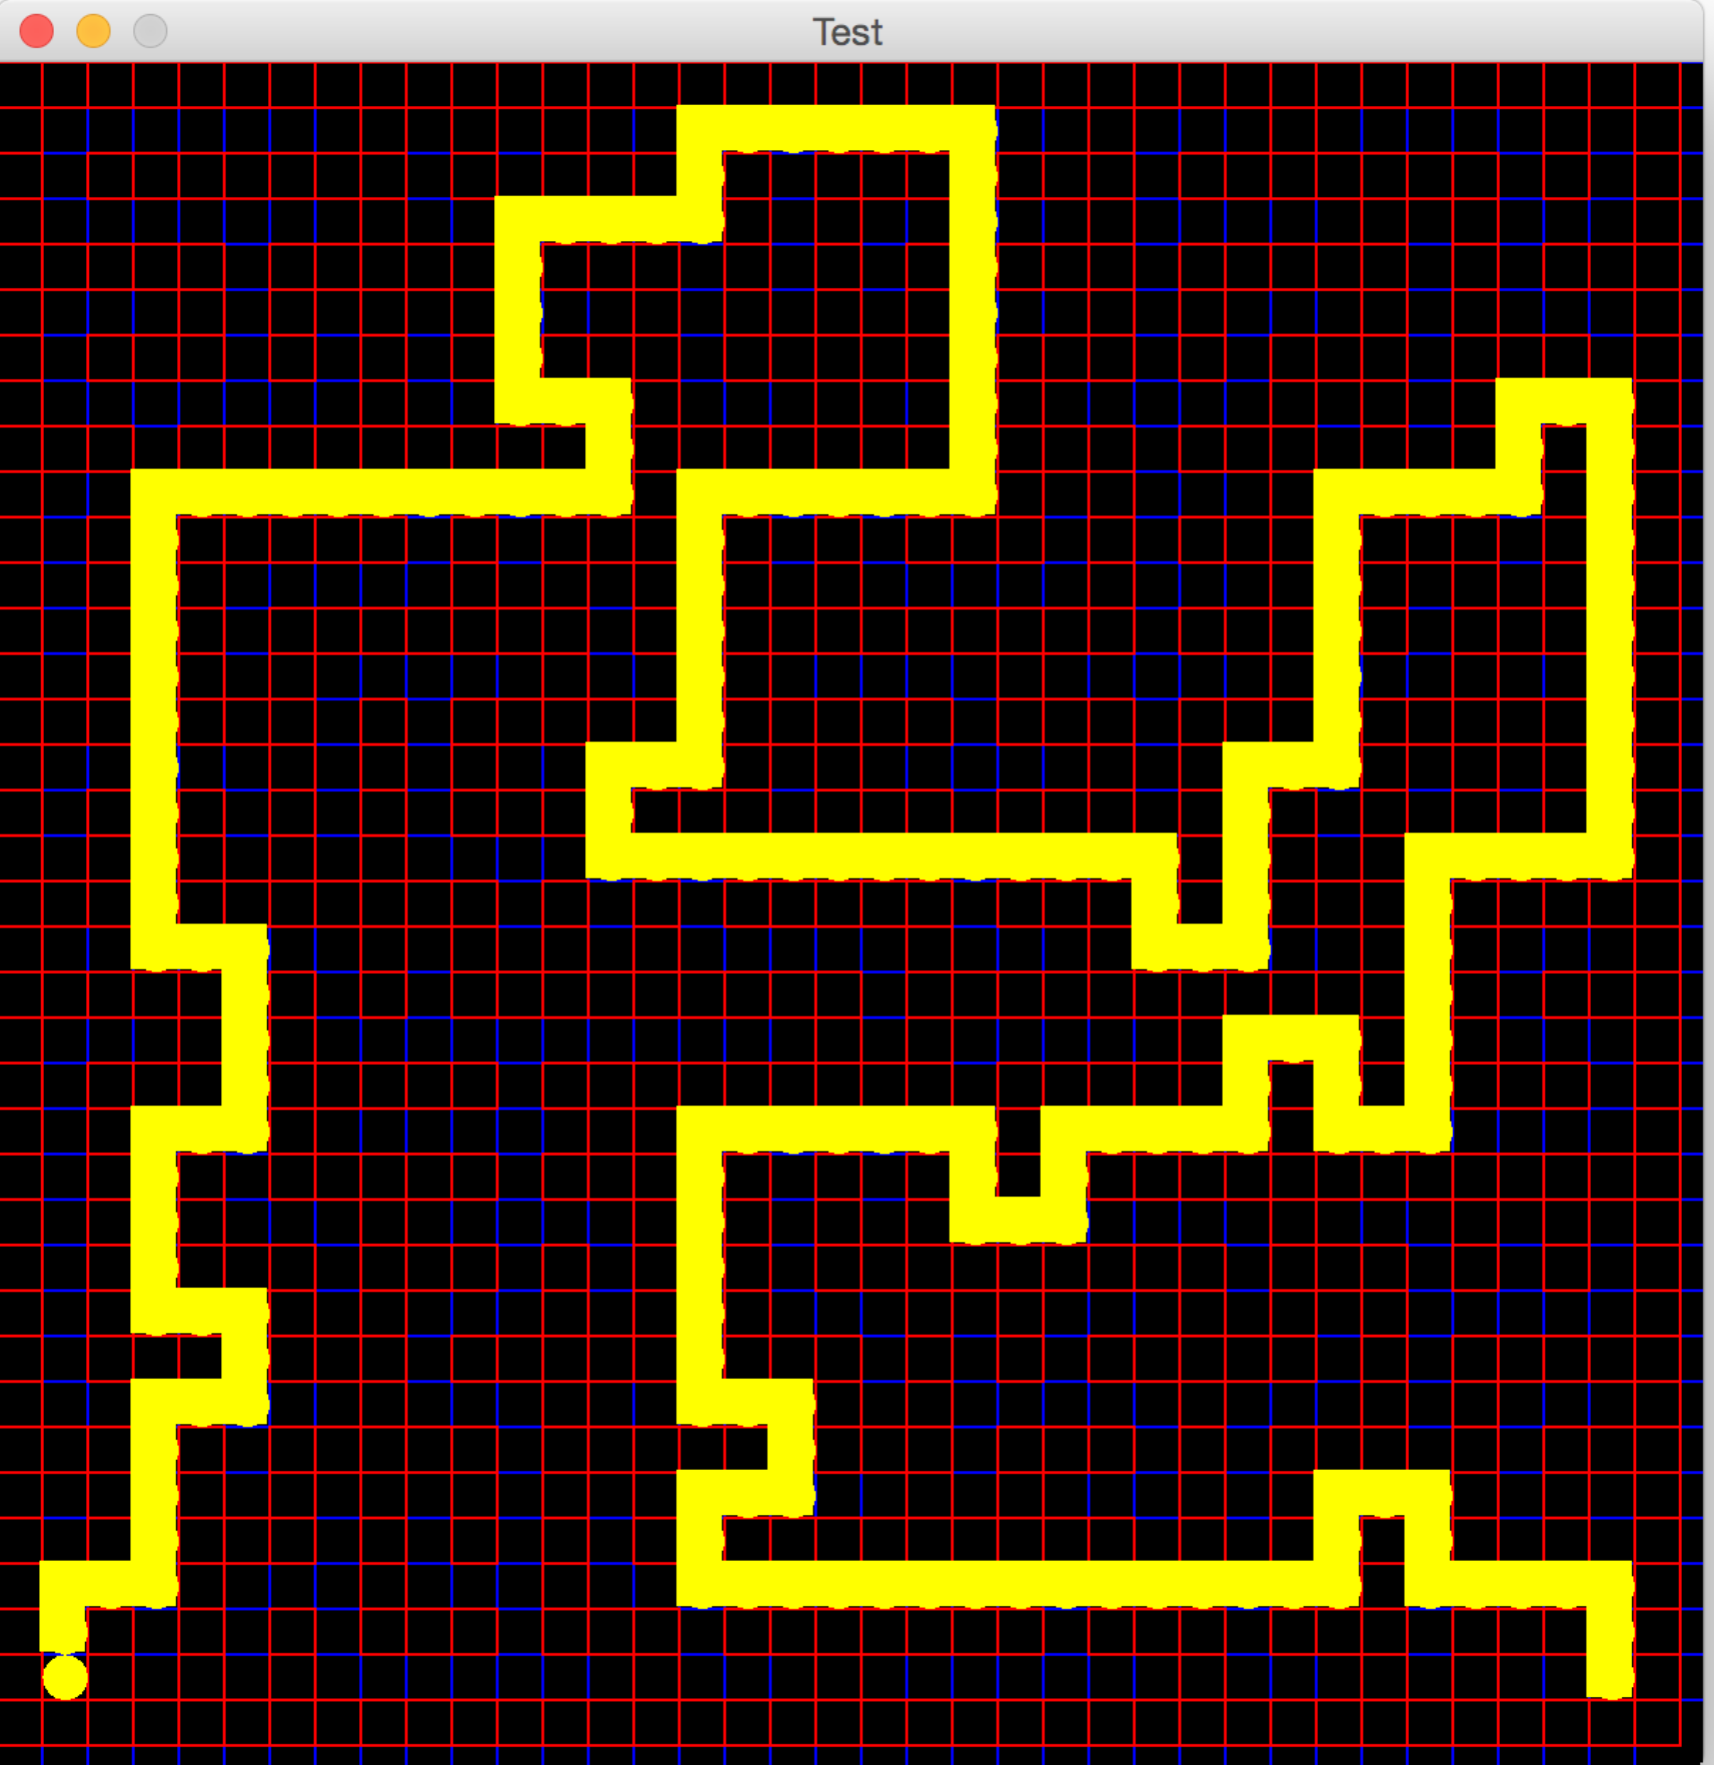

## Breadth First Search [bigMaze.txt]

**Path Explored : 620 Path Cost : 210**

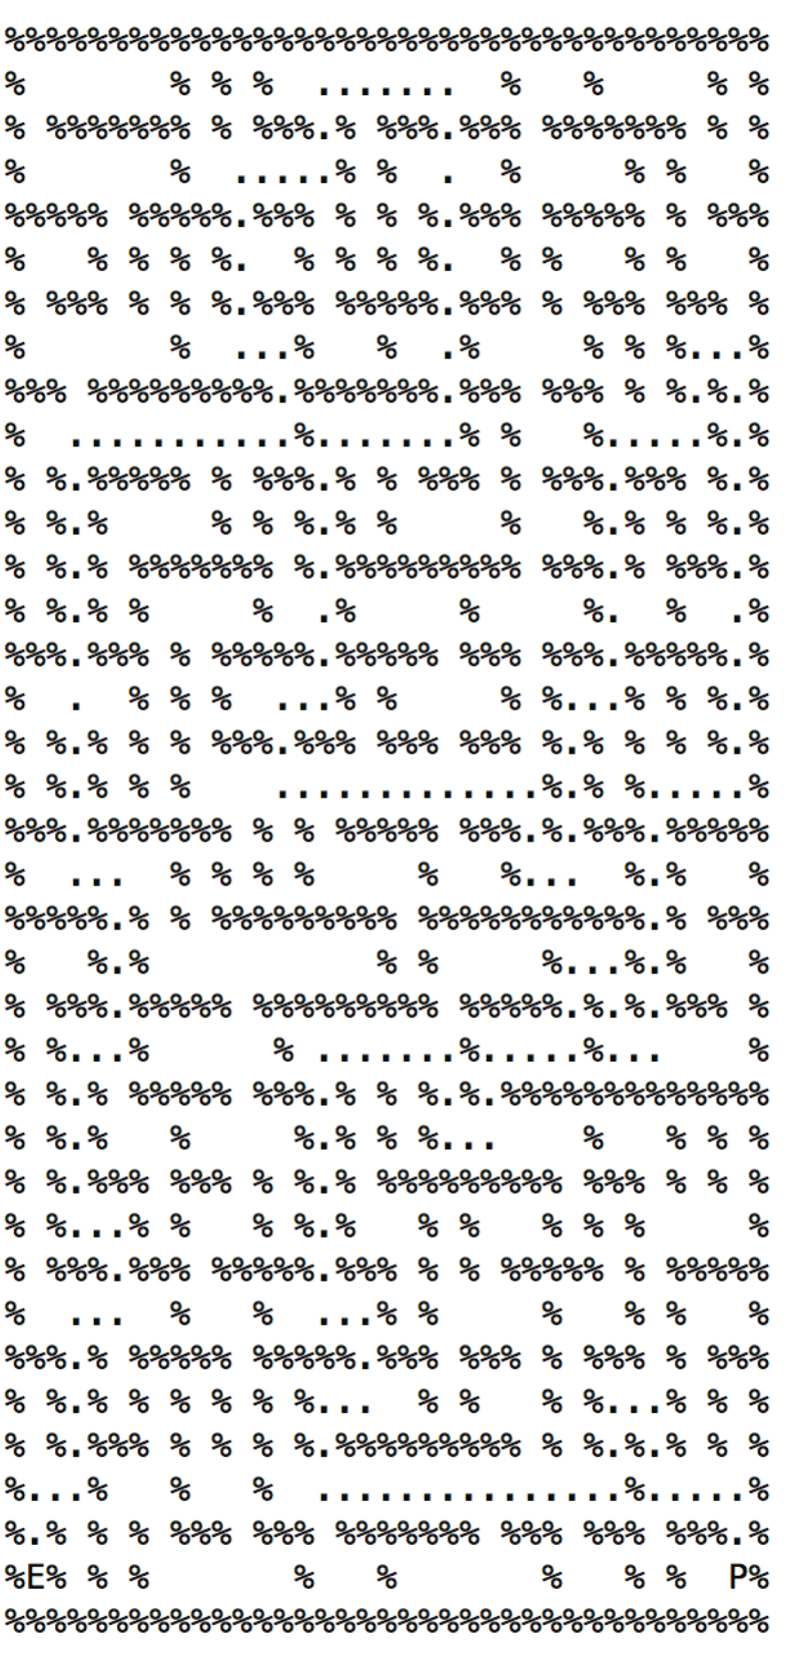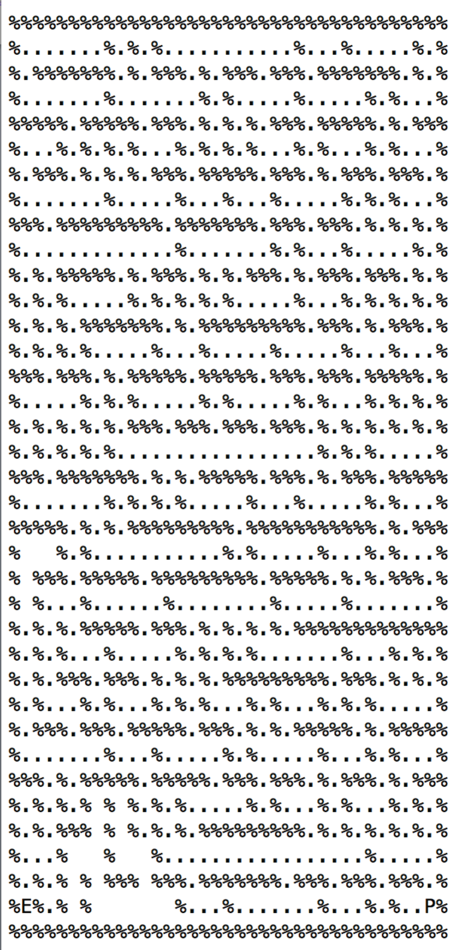

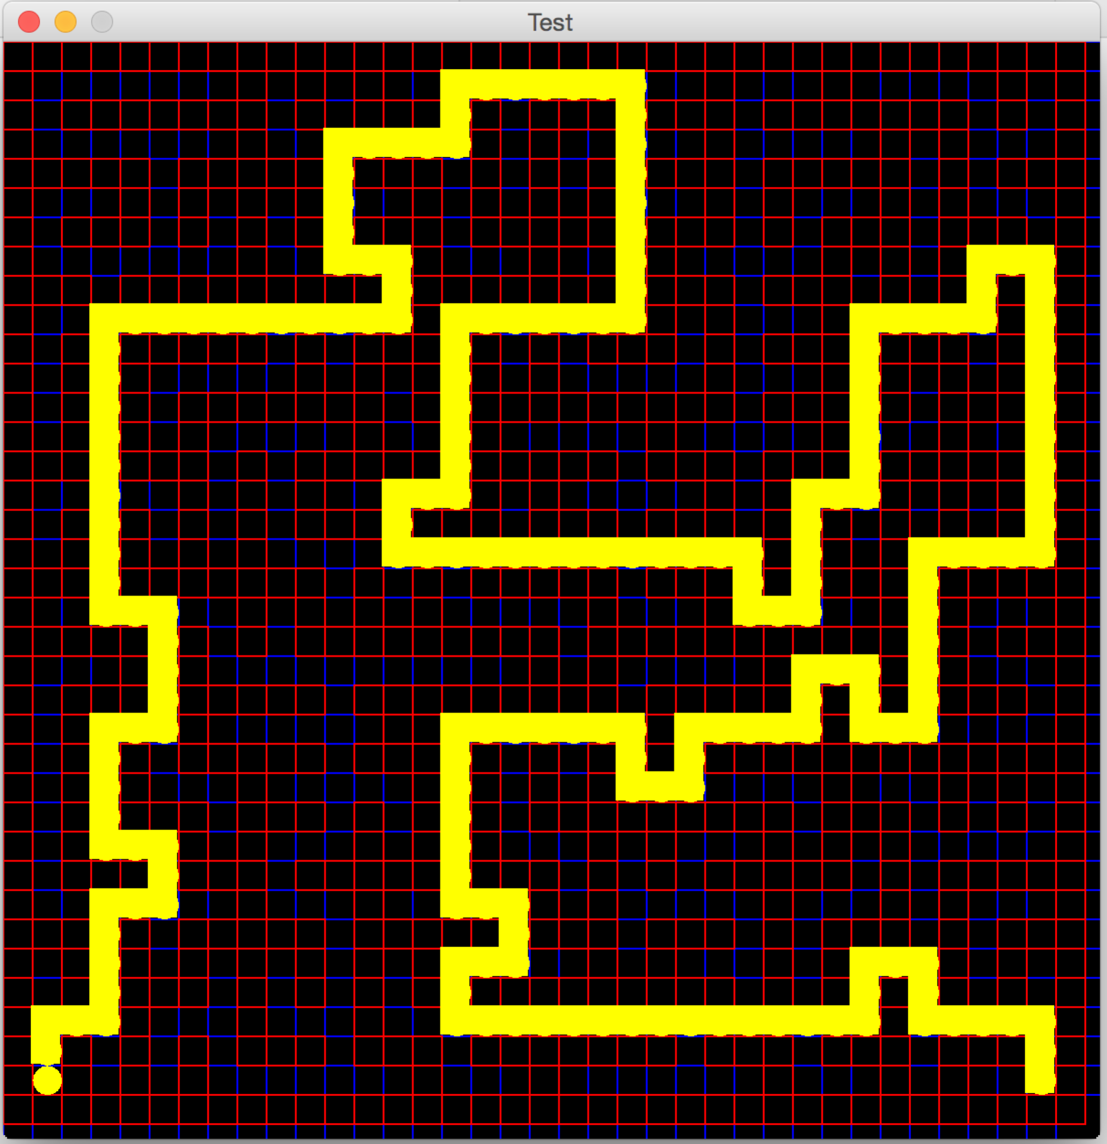

## Greedy Best First Search [BigMaze.txt]

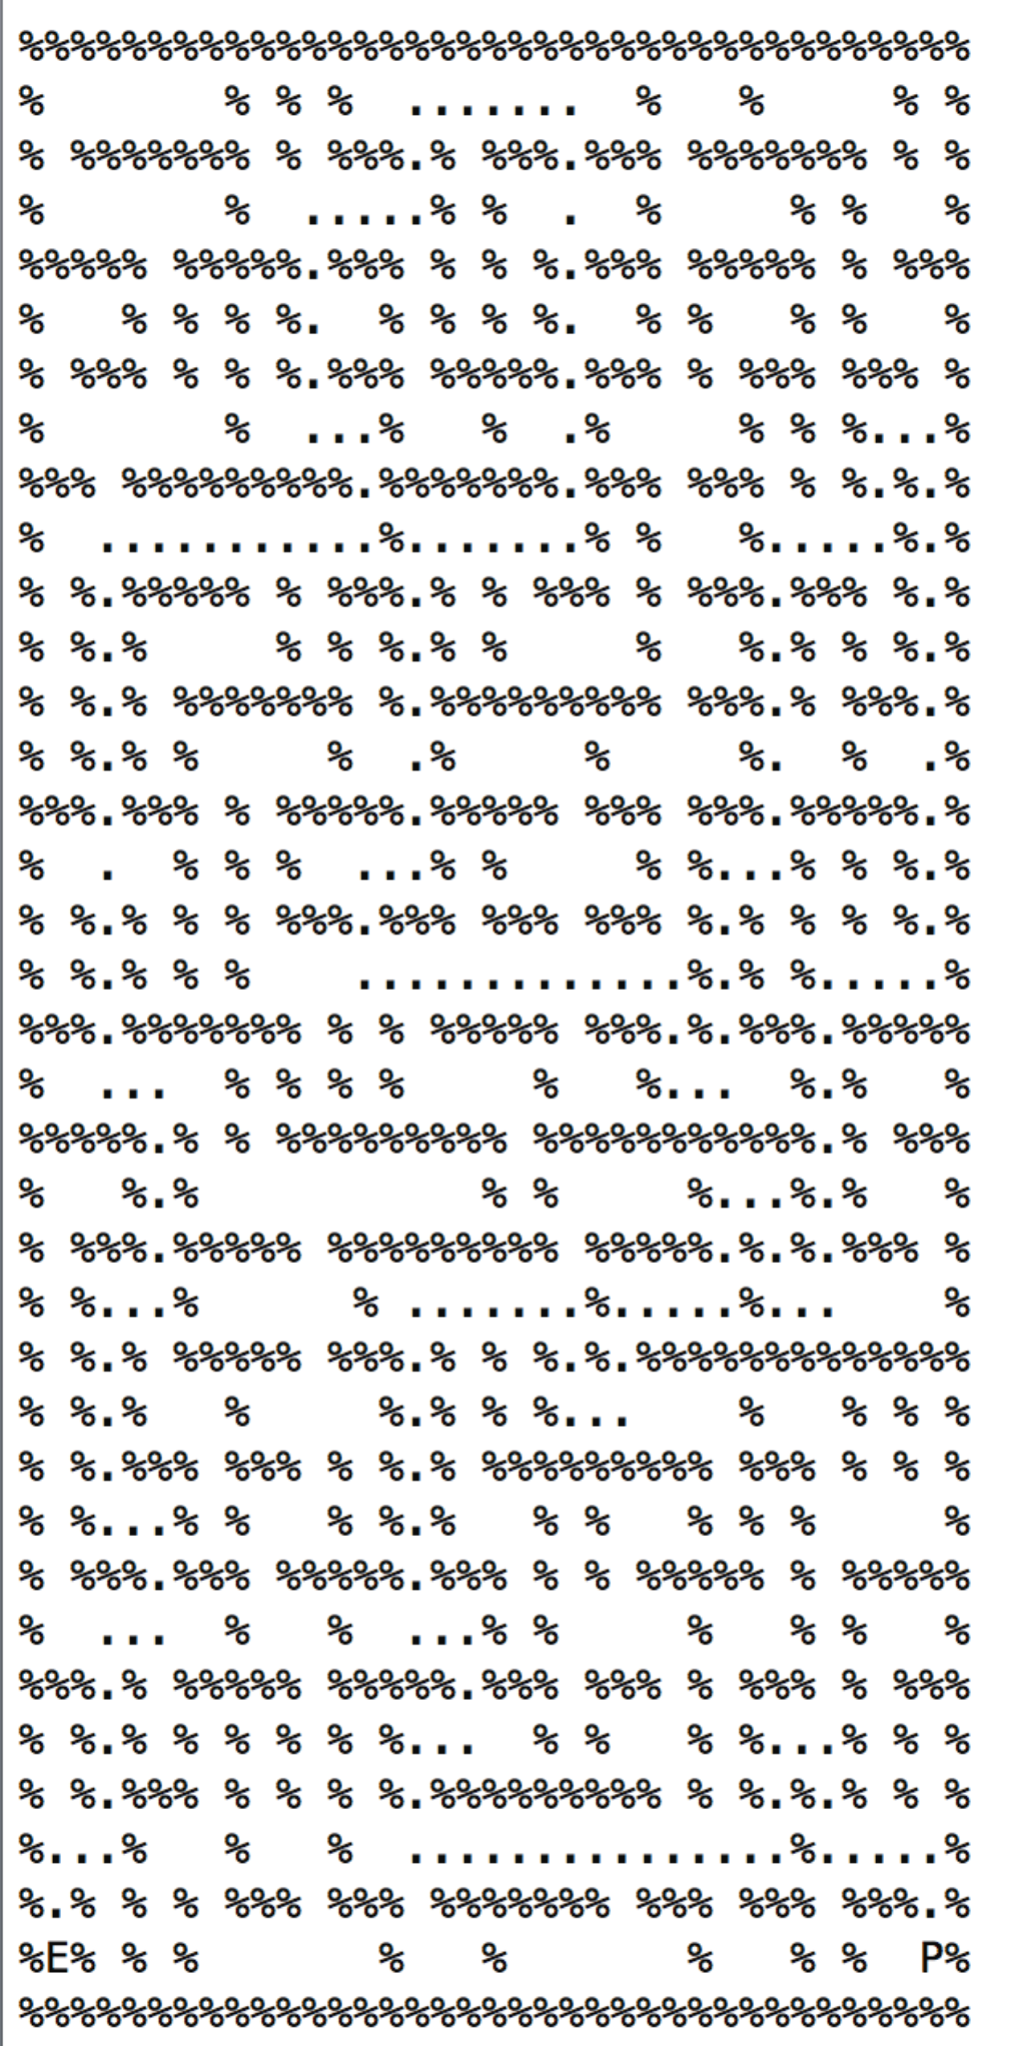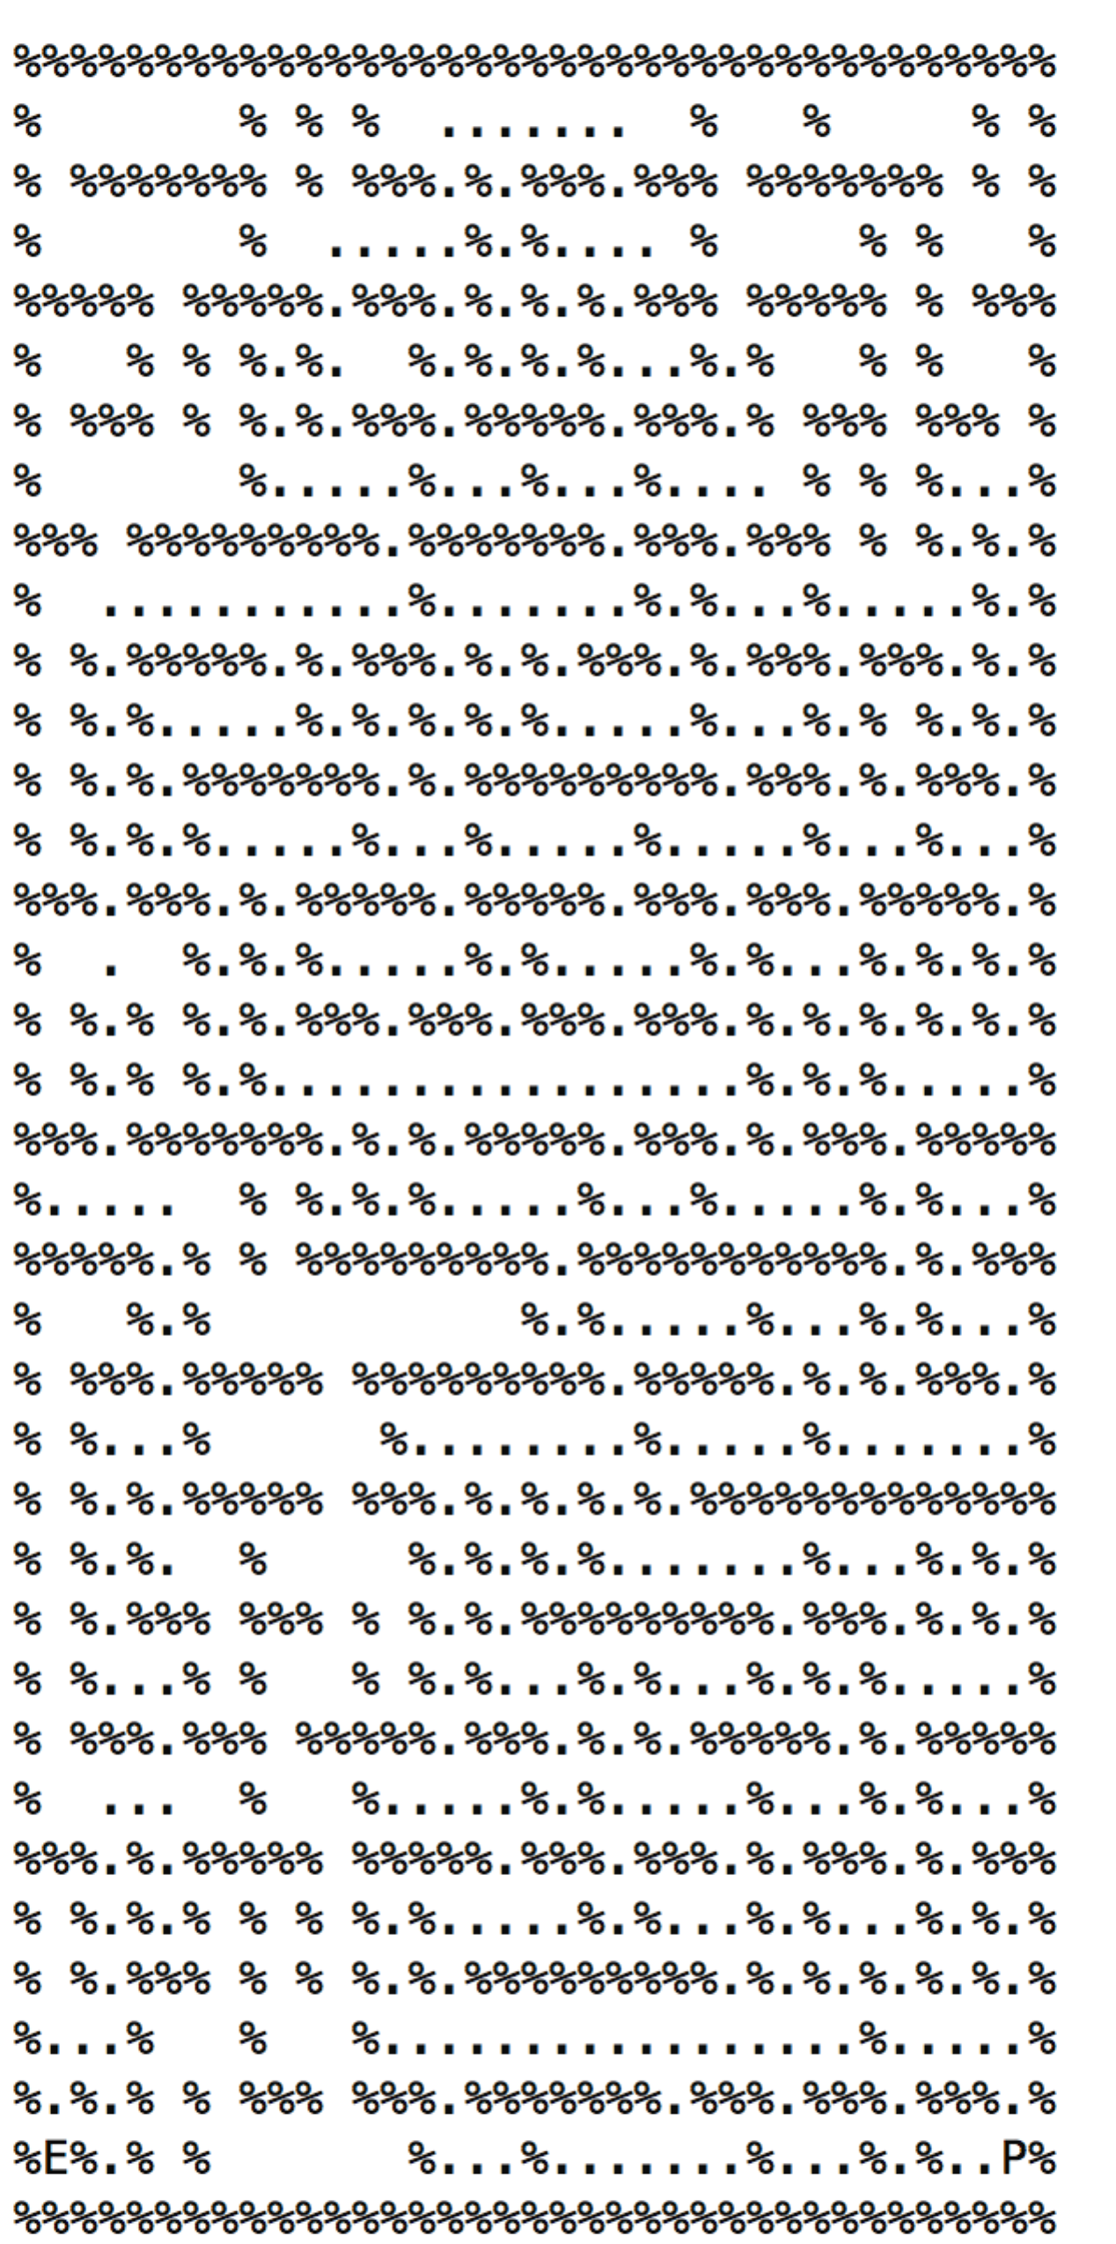**Path Explored : 464 Path Cost : 210**

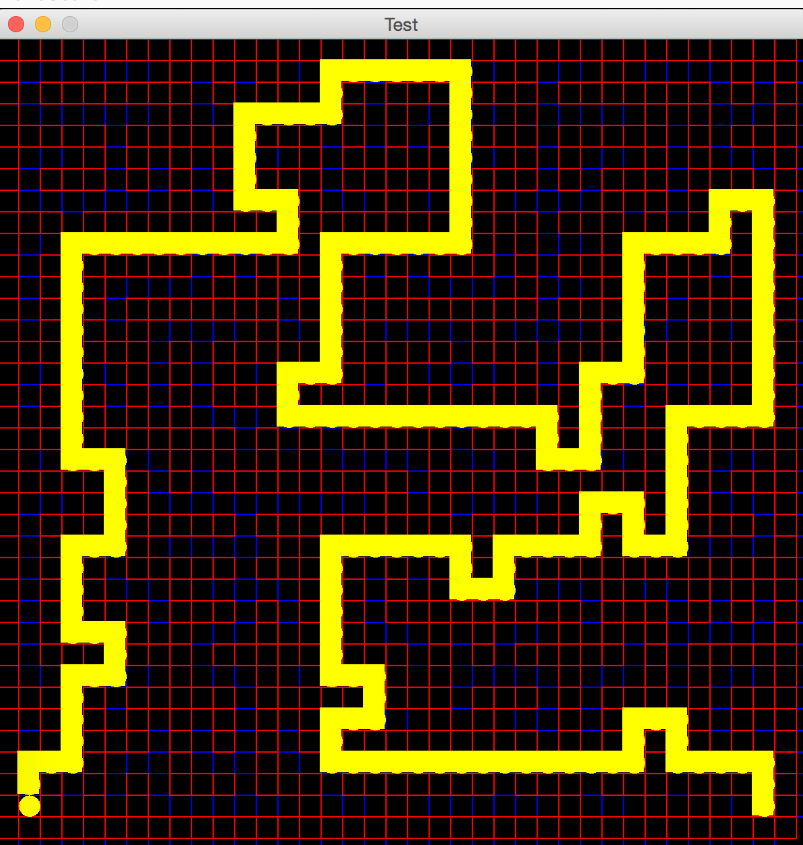

## ASTAR Search [BigMaze.txt]

**Path Explored : 549 Path Cost : 210**

